Devops workflow

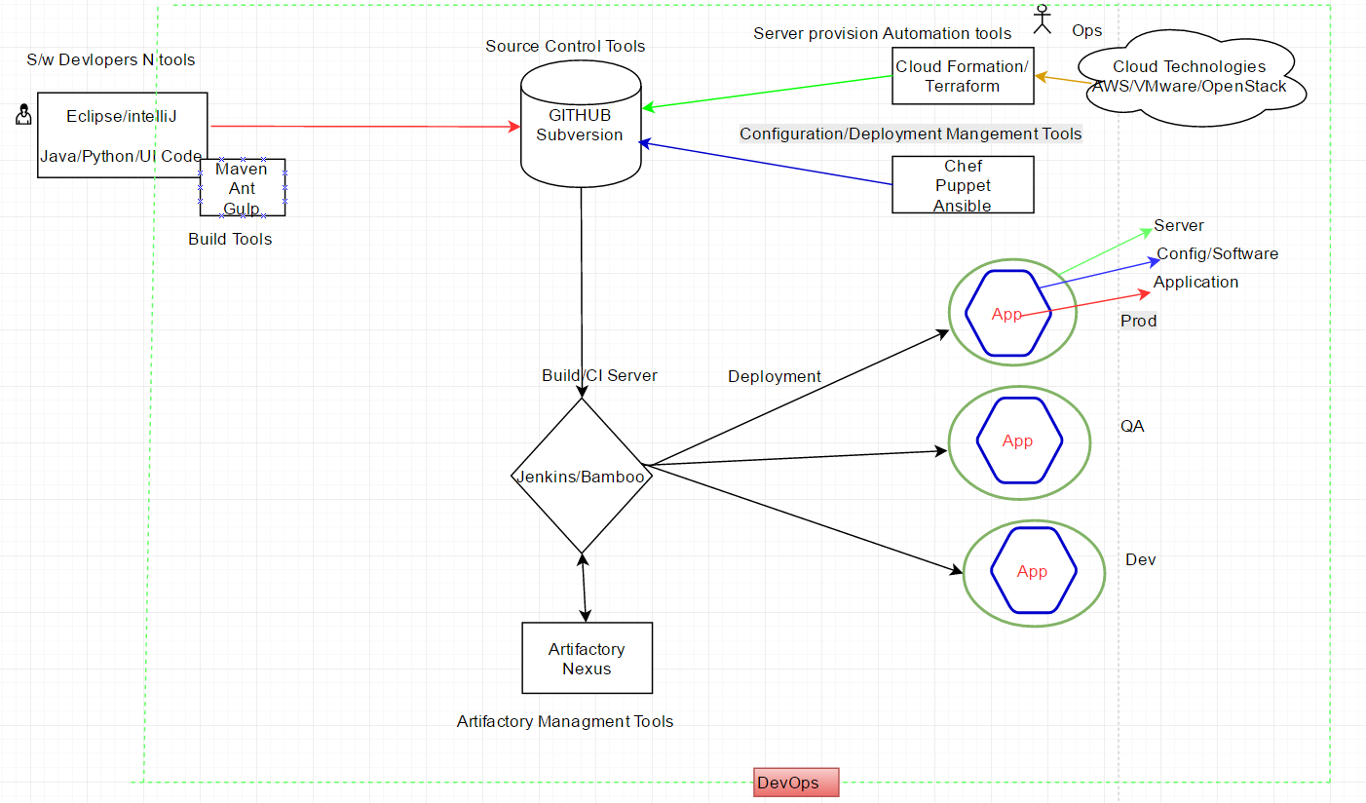

DevOps Engineer Will work on all of the tools (choice of tools may vary from environment to environment) as part of day to day job duties.

**Servers Provisioning Technologies:**Amazon Web Services (AWS), Open stack , VMware,Cloud front, Microsoft Azure , Google Cloud, Digital ocean are most popular Infrastructure providers/technologies used across most of the organization in cloud and on-premise.

**Configuration/Deployment Management Tools** : Ansible, Chef, Puppet,Salt Stack,u Deploy are the more popular automation tools used to maintain the configuration management and also to deploy the code to different environments (Dev, QA,Pre-Prod, Prod).

**Continuous Integration Servers** : Jenkins, Hudson, Bamboo, Travis CI are the commonly used CI tools to automate application code test,build,deploy as well as extended to automate the Infrastructure provision and destroying integrated with Server Provisioning Technologies and configuration management Tools.

**Artifactory management Tools** : In any enterprise/local environment we will store the versioning of executable file of our product in the form artifacts for our easiness. Nexus and Artifactory are the most popular and widely used artifactory management tools to store the executable artifacts across the organization.

**Source Code Version Management Tools** : GitHub, Git lab,Subversion, Perforce, CVS and Bit Bucket are the most popular tools in this segment.The code developed by developers/engineers will has to be collaborated and to be saved at a single place for daily and future developments activities and also it is very important to maintain the versioning of the code for easy maintenance/ reference purpose.

**Build Tools** : Maven, Ant,Gulp,Gradle are tools to build your source code that will be understandable by JVM for Java projects. Any source has to be build and compile so that it should be understandable to a machine language form.